https://www.youtube.com/watch?v=yF9SwL0p0Y0
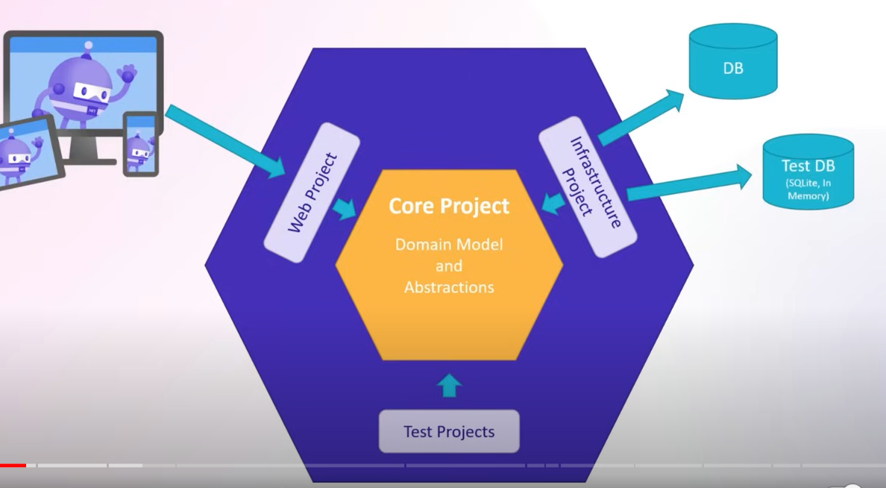

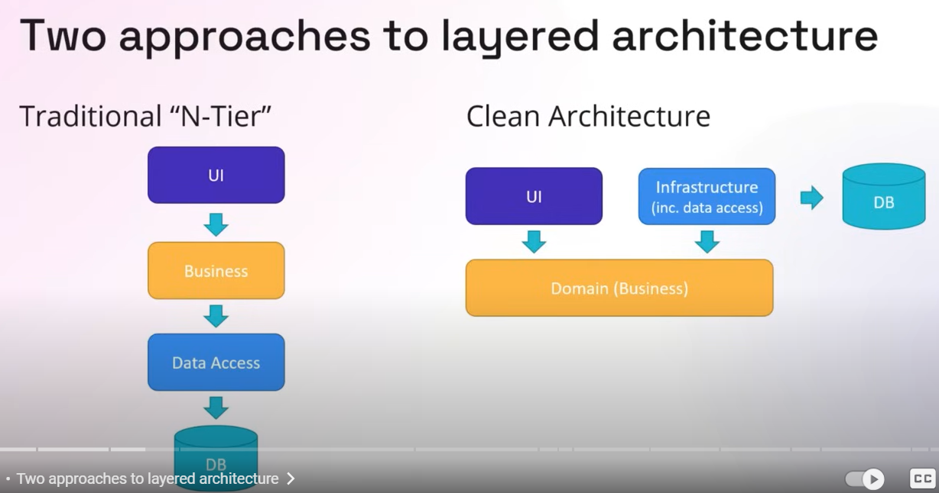
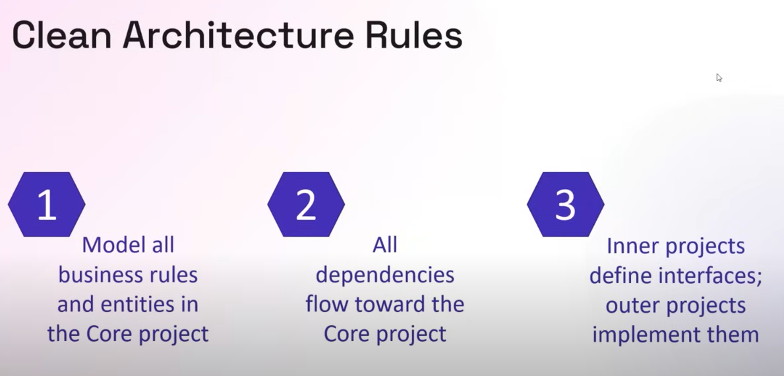

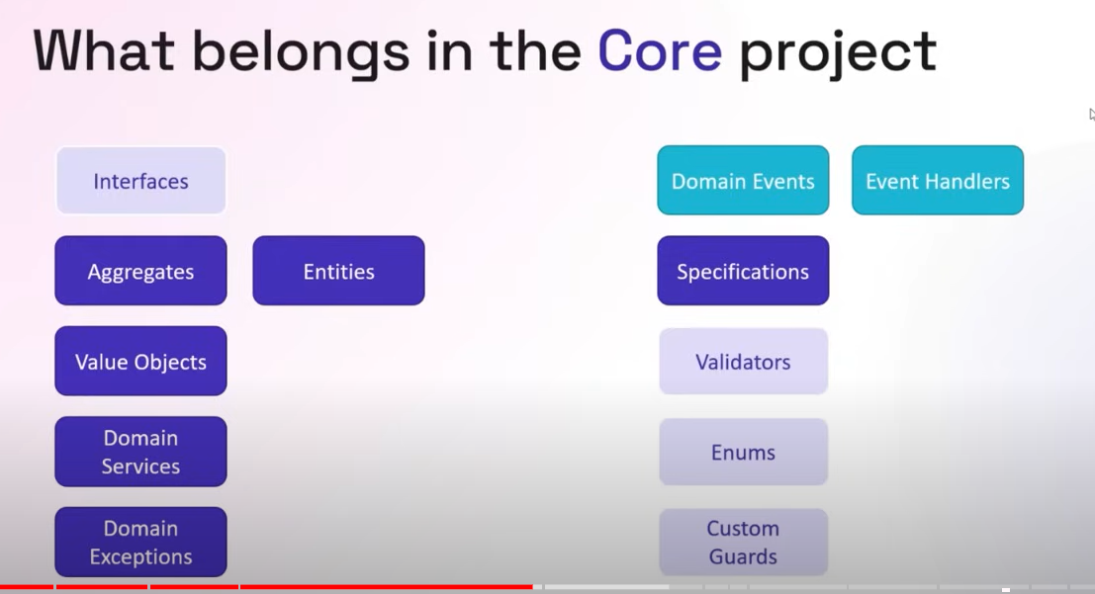
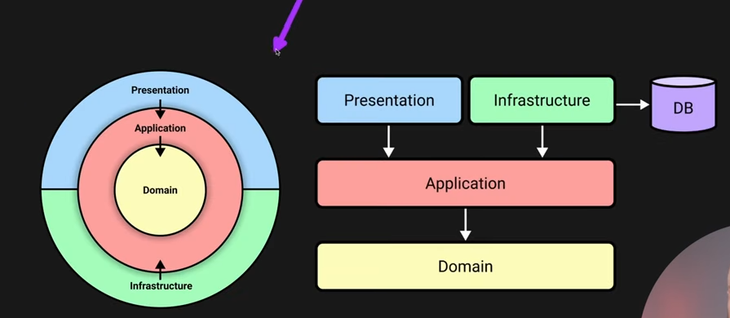
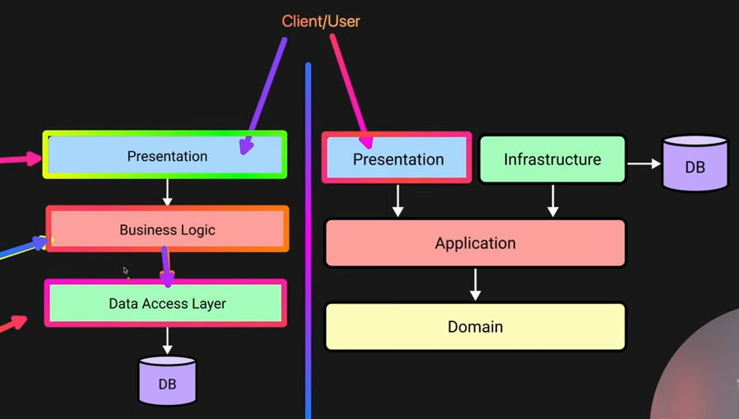
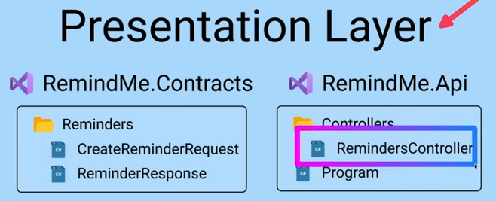
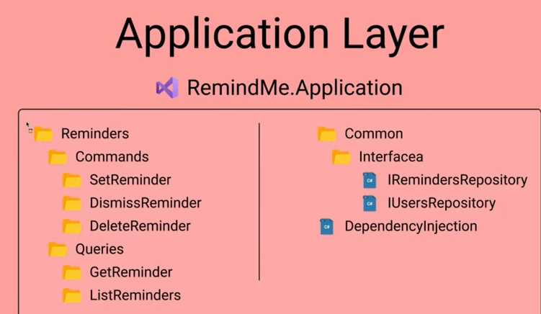
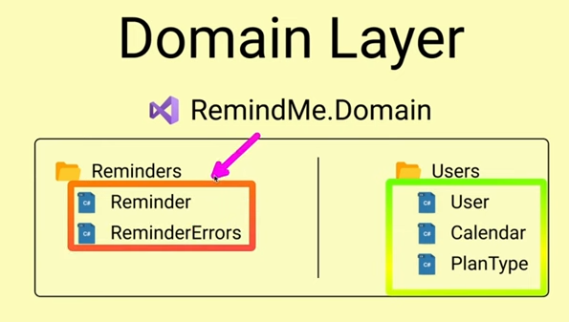
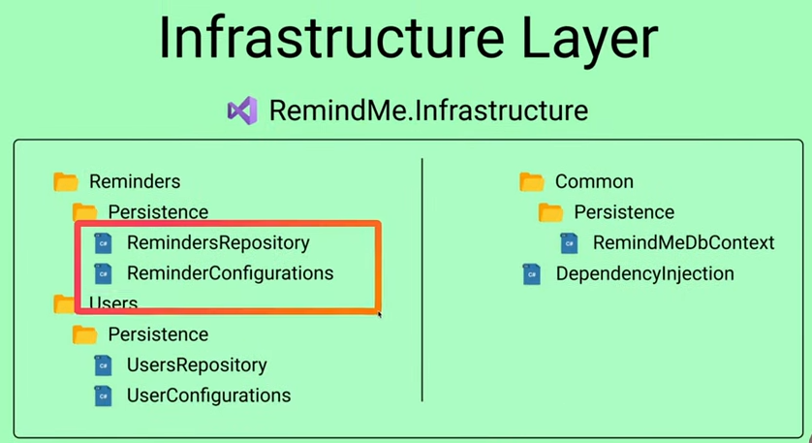

- It is domain centric architecture
- It ensures core business rule remain stable even if technologies change
- Separation of concerns
- Framework independence
- High testability
- Easy technology replacement
- Supports domain driven design

Few more points
- Presentation layers contains controllers
- Application layer contains , commands , queries , repository interfaces
- Domain layer contains domains
- Infrastructure layer contains the implementation of repository interfaces

